# Supporting Doc

**1 and 2:**

**Rank and Bar Chart:**

The locations that are hit by the crooks are sorted by the **ranks**, most hit location being in the top ranked.

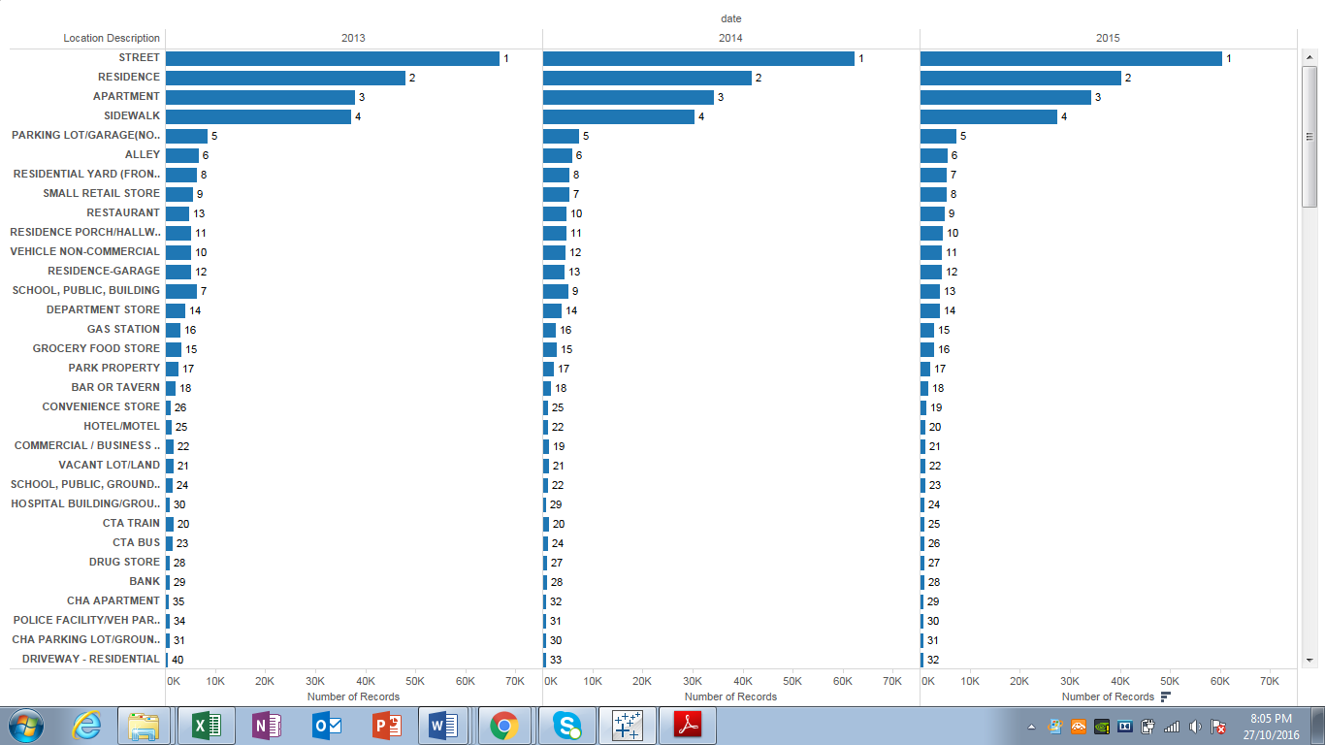

**3 and 4:**

**Group and Reference Line:**

In this visualization we analyzed the top crimes that are reported each year and found out the Average number of the crime. We have used the **Reference Line** to get the results. Out of several hundreds of crimes we have made **Groups** ofcrimes that were happening more frequently over the years. So under the Group ‘ASSAULT’ contains several hundreds of different types of crimes related to assault. Group ‘BATTERY’ contains several hundreds of different types of crimes which comes under crime of battery and so on for the other groups as well.

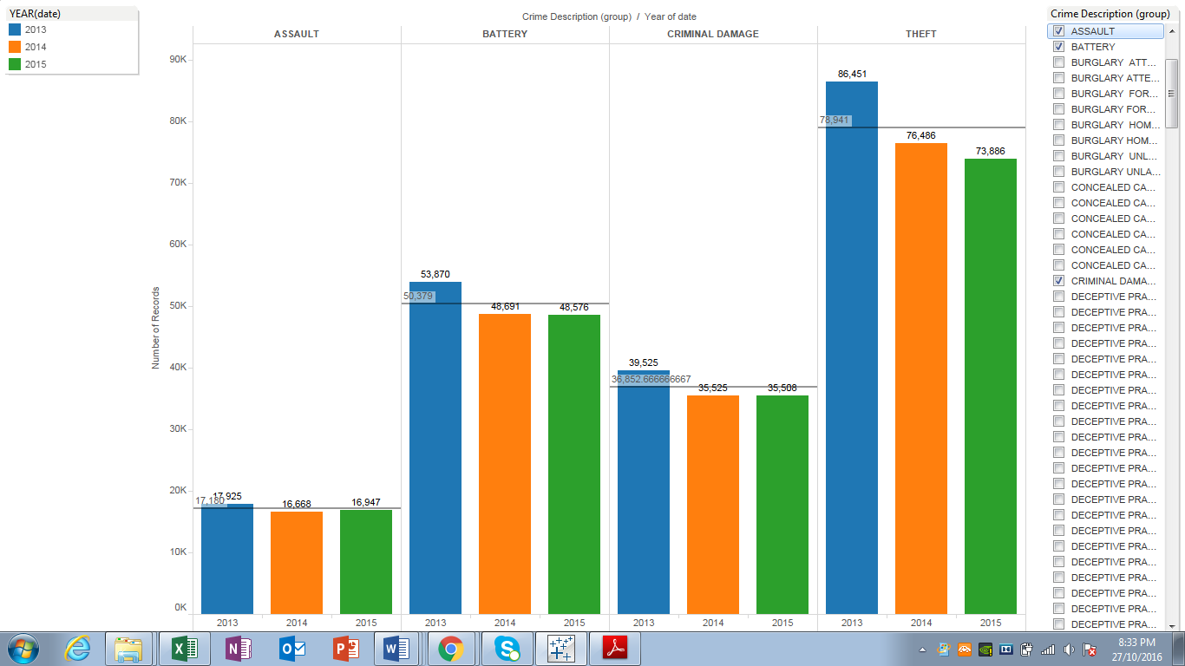

**5 and 6:**

**Forecast Trend Lines and Dates:**

Forecast is generated about the number of crimes to be anticipation in upcoming years using dates.

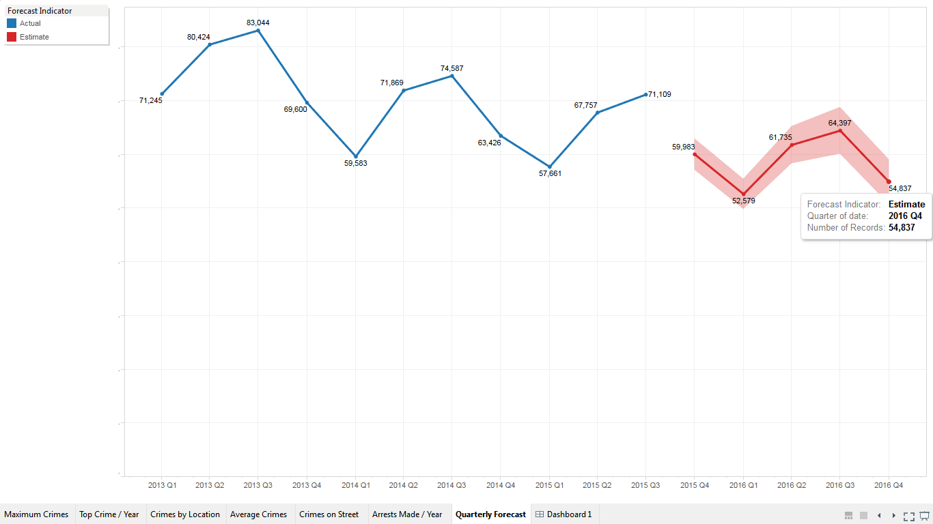

**7:**

**Treemaps:**

Here is the tree-map with filters concerning the particular year and most crime prone location i.e. Streets.

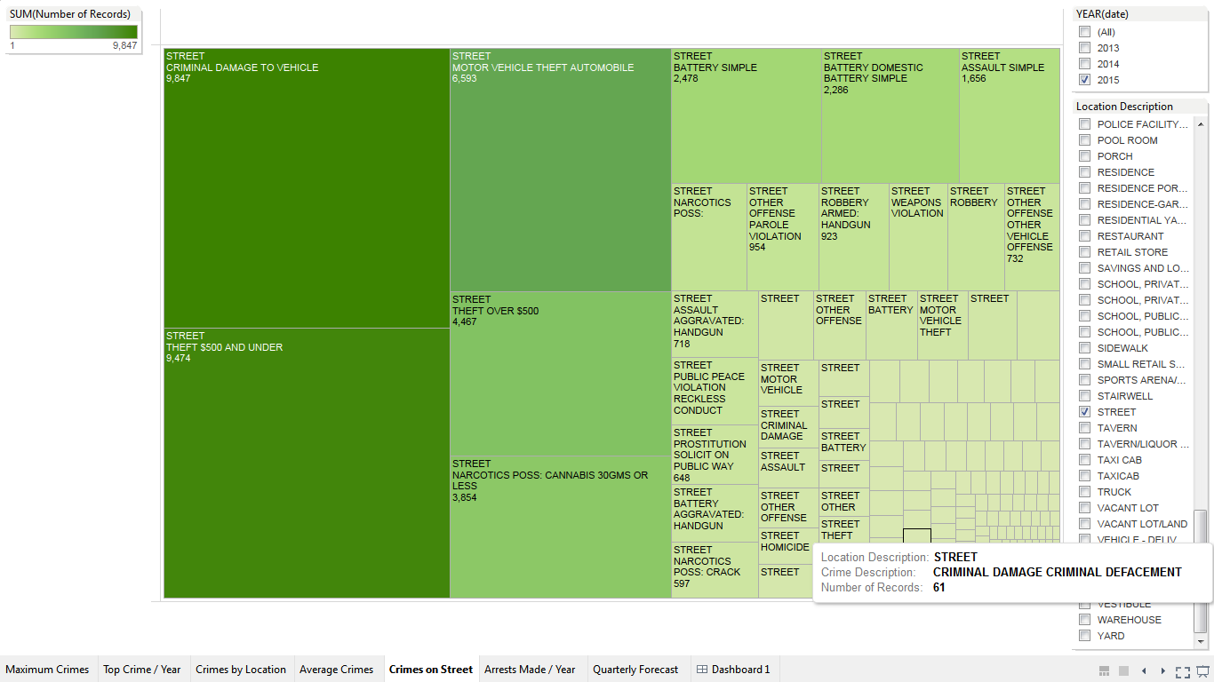

**8:**

**Packed Bubbles:**

In this visualization we have used the **Packed Bubbles** and found out the most occurring crime in the city of Chicago.

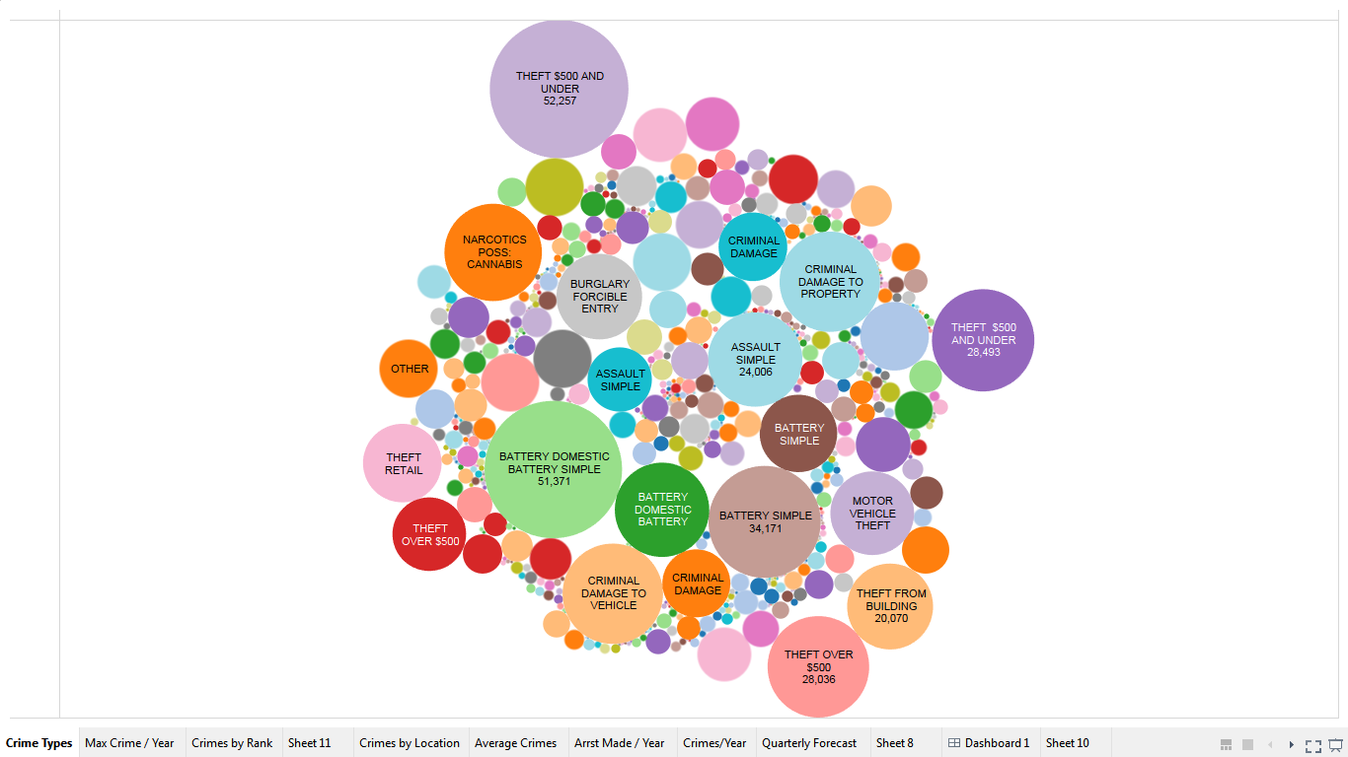

**9:**

**Shapes and Symbols:**

The Filter has been applied in the following visualization to find out top crimes in different years.

